∂Assessment Schedule – 2013

Chemistry: Demonstrate understanding of the properties of selected organic compounds (91165)

Assessment Criteria
Achievement | Achievement with Merit | Achievement with Excellence
Demonstrate understanding involves naming and drawing structural formulae of selected organic compounds (no more than eight carbons in the longest chain) and giving an account of their chemical and physical properties. This requires the use of chemistry vocabulary, symbols and conventions. | Demonstrate in-depth understanding involves making and explaining links between structure, functional groups and the chemical properties of selected organic compounds. This requires explanations that use chemistry vocabulary, symbols and conventions. | Demonstrate comprehensive understanding involves elaborating, justifying, relating, evaluating, comparing and contrasting, or using links between the structure, functional groups and the chemical properties of selected organic compounds. This requires the consistent use of chemistry vocabulary, symbols and conventions.
Evidence Statement
One | Expected Evidence | Achievement | Merit | Excellence
(a)(i)  (ii) | A  Chlorine/the functional group is attached to a C atom (C2), which has two other C atoms attached to it. | - (a) (i) and (ii) correct.  - (b) correct molecules chosen.  - (c) (i) geometric isomers drawn.  - (c) (ii) geometric isomers described in terms of thdedouble bond / two different groups.  - (d) THREE names or structural formulae correct. | - In (b) same number and type of atoms (molecular formula)  AND  arranged differently (structural formula)  linked to A and F.  In (c)(ii):  - non rotational double bond with cis-trans isomers shown in diagram  - (two) different groups on C atom with groups stated. | In (b) and (c) requirements for constitutional isomers (including position of Cl) AND geometric isomers (including rotation) linked to molecules.
(b)  (c)(i)  (ii)  (d) | A and F  Constitutional / structural isomers have the same molecular formula (they have the same type and number of atoms) but different constitutional / structural formulae (atoms are arranged differently).  These molecules both have the same number and type of atoms but the atoms are arranged differently; C₄H₉Cl / the chlorine is on a different carbon atom.  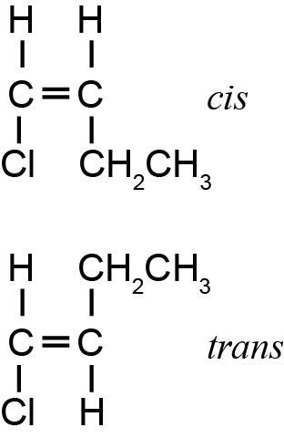  Cis-trans isomers can occur in molecules that have (carbon to carbon) double bond because atoms are not free to rotate around (the axis of) the double bond. They must also have two different groups attached to each carbon (involved in the double bond).  This molecule has a carbon-carbon double bond. One carbon of the double bond is attached to a hydrogen atom and an ethyl group. The other is attached to a hydrogen atom and a chlorine atom.  See Appendix One.

NØ | N1 | N2 | A3 | A4 | M5 | M6 | E7 | E8
No  response or no relevant evidence. | 1a | 2a | 3a | 4a | 2m | 3m | e  with minor error / omission / additional information. | e

Appendix One: Question One (d)

Structural formula | IUPAC  (systematic) name
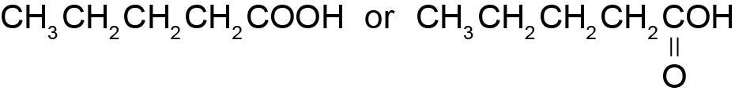 | pentanoic acid
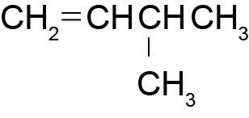 | 3-methylbut-1-ene
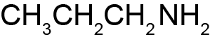 | 1-propanamine /  1-aminopropane (propyl amine)
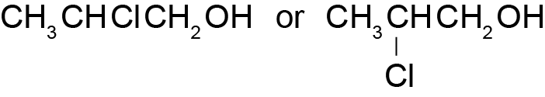 | 2-chloropropan-1-ol
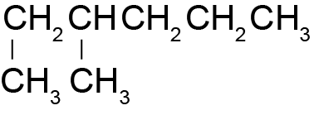 | 3-methylhexane

Two | Expected Coverage |  |  |  | Achievement |  |  | Merit |  |  | Excellence
(a)(i)  (ii) | Correct polymer (two repeating units).  Correct monomer molecule.  See Appendix Two. |  |  |  | - (a) (i) correct.  - (a) (ii) correct.  - In (b) solubility of one liquid correct.  - In (b) litmus colour change for amine correct  - In (b) colour change with bromine water for one liquid correct. |  |  | In (b):  Water used to distinguish between liquids (minor error).  Litmus used to distinguish between liquids.  Bromine water used to distinguish between liquids. |  |  | In (b) a valid method that distinguishes between the liquids.
(b) | Water  Add water to the five liquids. Two solutions will dissolve in water (ethanol, ethanamine), three will not (pentan-1-ol, pent-1-ene and pentane).  Litmus  Use the solutions formed by dissolving in water. Add red litmus paper to both solutions.  One will not change the colour of the litmus paper; this is ethanol.  One will turn red litmus blue; this is ethanamine.  Bromine water  Test the liquids that did not dissolve in water by reacting fresh samples with bromine water. Pent-1-ene will (rapidly) turn the orange solution to colourless. (UV) light is required for the reaction with pentane / Br₂ does not react with pentane / no colour change / slow colour change. The remaining liquid is pentan-1-ol.  (Accept that pentane and pentan-1-ol cannot be separated by this method if this is outlined).
NØ |  | N1 | N2 | A3 |  | A4 | M5 |  | M6 | E7 |  | E8
No  response or no  relevant evidence. |  | 1a | 2a | 3a |  | 4a | 2m |  | 3m | e  with minor error / omission / additional information. |  | e

Appendix Two: Question Two (a)

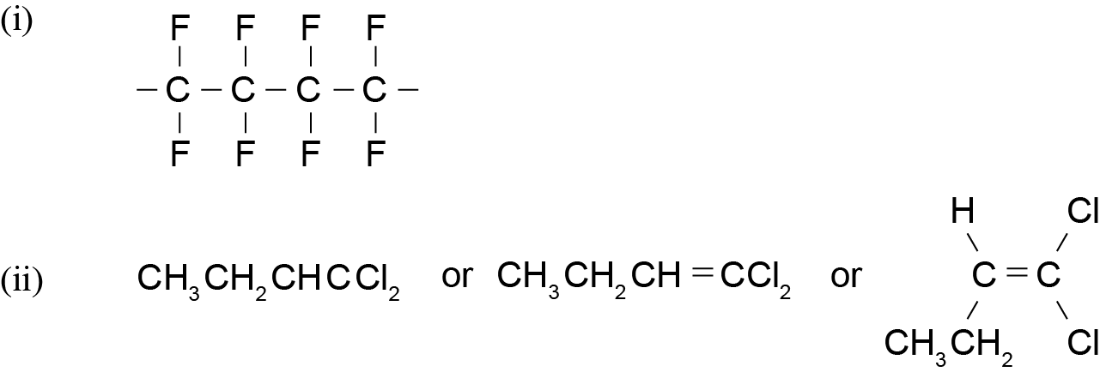

 | Three | Expected Coverage |  |  |  |  | Achievement |  | Merit |  |  | Excellence
 | (a)(i) | See Appendix Three. |  |  |  |  | - In (a) (i) TWO reagents correct.  - (a) (ii) major product with reason.  - In (a) or (b) TWO different reaction types identified.  - In (b) ONE functional group correct.  - In (b) ONE formula of product correct. |  | In (b):  For the substitution reaction forming chlorobutane  The type of reaction plus TWO of the following correct:  reason, functional group, formula of the organic product.  For the oxidation reaction forming butanoic acid:  The type of reaction plus, the functional group, AND the formula of organic product correct.  For the elimination reaction forming but-1-ene:  The type of reaction plus TWO of the following correct: reason, functional group, formula of the organic product. |  |  | In (b) elaborates all THREE reactions fully.
 | (a)(ii) | Major product – the carbon with the least hydrogen atoms attached loses another hydrogen atom (to form the double bond).
 | (b) | Reaction with PCl₅ is a substitution reaction. The hydroxyl group (–OH) is replaced by a chloro group (–Cl).  The product is CH₃CH₂CH₂CH₂Cl  The functional group in the product is a chloro group / chloroalkane (haloalkane).  Reaction with acidified dichromate is oxidation as the alcohol is oxidised to a carboxylic acid.  The product is CH₃CH₂CH₂COOH  The functional group in the product is carboxylic acid.  Reaction with concentrated H₂SO₄ is an elimination reaction. A hydrogen atom and the –OH group on (adjacent) carbon atoms are removed forming a (carbon-to-carbon) double bond.  The product is CH₃CH₂CH=CH₂  The functional group in the product is a (carbon-to-carbon) double bond / alkene.
NØ |  |  | N1 | N2 | A3 | A4 |  | M5 |  | M6 | E7 |  | E8
No  response or no  relevant evidence. |  |  | 1a | 2a | 3a | 4a |  | 2m |  | 3m | e  with minor error / omission / additional information. |  | e

Appendix Three: Question Three (a)

Reagent | Formula of reagent / conditions | Type of reaction
A | H₂O/H⁺ | addition
B | PCl₅ / PCl₃ / SOCl₂ | substitution
C | KOH (alc) | elimination

Judgement Statement
 | Not Achieved | Achievement | Achievement with Merit | Achievement with Excellence
Score range | 0 – 7 | 8 – 14 | 15 – 18 | 19 – 24

